Helsinki, Finland 6.1.2012
The World’s First Solo Run Across the Sahara Desert tracked with Sports Tracker
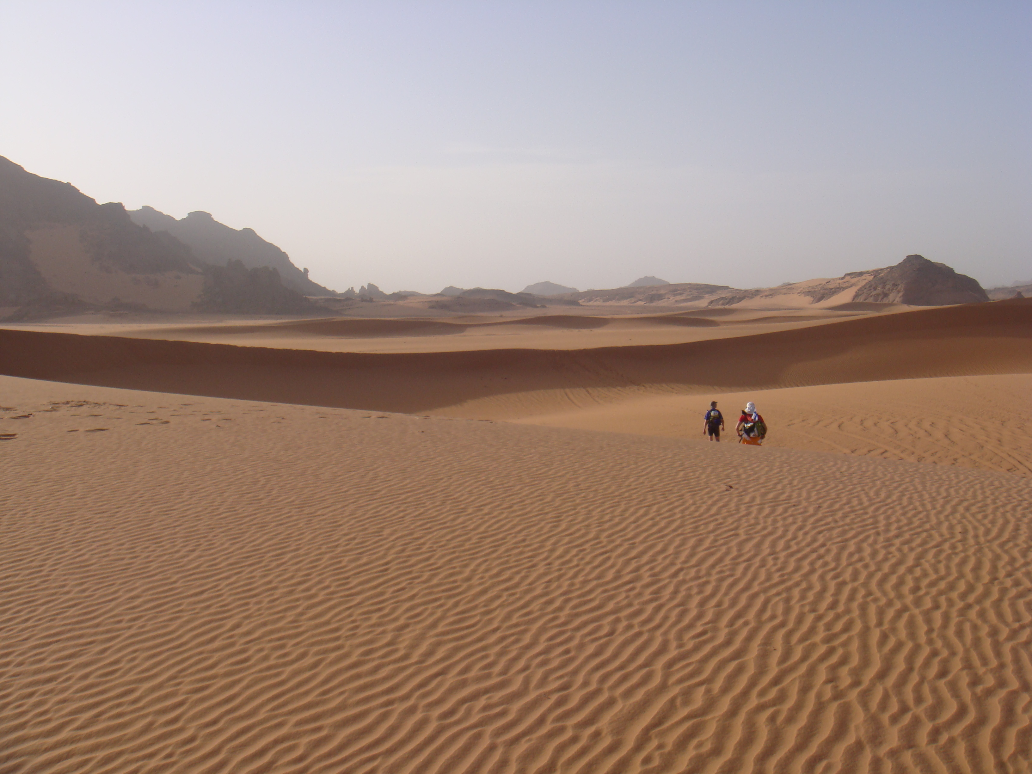
Starting today (6th of January 2012) Finnish ultra runner Jukka Viljanen is attempting to run a demanding route across Sahara, covering approximately 2000 kilometers (1242 miles) during 35 days. That’s 50 km (31 miles) per day. To the best of our knowledge this is the first time that anyone will be running a full crossing of the Sahara solo.

Running such a long distance over a short period of time will prove a major challenge – both mentally and physically. Jukka will consume between 5,000 and 7,000 Calories each day and cover the distance of over 40 marathons in 35 days.

Jukka will be tracking and sharing his record breaking attempt online using a Nokia E5 smartphone and Sports Tracker – the #1 free sports tracking application for iPhone, Android, Windows Phone and Nokia smartphones. The Sports Tracker app will capture the duration, length, speed, average speed and pace of the attempt using the built-in GPS of the Nokia smartphone.

The daily progress of the attempt, using the data captured by Sports Tracker, can be followed on the challenge website, on Sports Tracker and on Twitter & Facebook.

Download images from the Sahara Challenge 2012:
www.saharachallenge2012.com/media/

Follow the Challenge online:
www.saharachallenge2012.com
www.sports-tracker.com/#/view_profile/sahara2012
www.twitter.com/runjukkarun
www.facebook.com/saharachallenge2012

In addition to Sports Tracker Jukkas’ attempt is supported by Nokia, Footbalance, Battery Hydro, Bridgedale, Petzl, Millet, Midsona, Camelbak and FRF.

About Jukka Viljanen
Outside of his adventures Jukka works mainly as a corporate & motivational speaker and guides trekking and running trips to Nepal, Kalahari and other wild places. He also works as a consultant for the Finnish running magazine “Juoksija”.
Jukka has a university degree in business and lives in Espoo, Finland.
His previous adventures include running across the Kalahari Desert (1000km), taking part in the North Pole Marathon, North Pole Bike Extreme and “The coldest 100km in the world” in Antarctica.
www.saharachallenge2012.com/about-jukka

About Sports Tracker
Track and analyze your performance, share workout data and photos with your friends, and most of all – get fit and stay healthier. Whether cycling, running or walking, Sports Tracker makes training more social and fun and helps its users live healthier and happier lives.
The Symbian version of Sports Tracker has dominated the download charts of Nokias’ Ovi Store and made a big splash when it launched on the iPhone and Android. It’s among the highest rated tracking apps on Android and iPhone and has been a TOP5 Health & Fitness app in more than 25 markets in the iPhone App Store. Apple also featured Sports Tracker as the #1 Health & Fitness app in their iPhone 4S launch. The app was also launched for Windows Phone in December 2011.
Together with the full-featured online service at www.sports-tracker.com – with detailed maps and an enhanced experience – and an active community of millions of users around the world in over 200 countries, Sports Tracker has been used to track more than 98 million training miles (159 million kilometers).
Sports Tracker online service:
www.sports-tracker.com
Download the free apps:
bit.ly/sportstracker_iphone
bit.ly/sportstracker_android
bit.ly/sportstracker_wp
bit.ly/sportstracker_nokia
bit.ly/sportstracker_n9
Sports Tracker blog
www.sports-tracker.com/blog
About Sports Tracking Technologies Ltd
Our mission is to help people connect through sports, train better and live healthier, happier lives. We do this by creating innovative tools for outdoor activity tracking and analyzing. Our products provide informative on-line training data and the possibility to share workouts and experiences with other trackers across the globe.
The Sports Tracker mobile application was originally created in 2004, when the founding team worked at Nokia Research Center. The founders had a vision of an easy and fun training application that would help people train better and connect with each other. The Nokia Sports Tracker Beta was launched in 2007 gathering a huge global following as the first application of it's kind to hit smart phones. The current company Sports Tracking Technologies was founded in 2009 after a successful spin-off from Nokia.
The application is the brainchild of Ykä Huhtala, Jussi Kaasinen and Antti Sorvari, who together hold over 25 years of experience from R&D, marketing and developing new mobile products and online services.
Media Contact
For more information, interview requests or a casual chat on all things Sports Tracker please contact:
Mr. Jussi Solja
+358 50 5328737
jussi.solja@sports-tracker.com
Skype: jussisolja

